Chapter
Introduction to Operations Management

Discussion Questions
1. The text suggests four reasons to study OM. We want to understand (1) how people organize themselves for productive enterprise, (2) how goods and services are produced, (3) what operations
managers do, and (4) this costly part of our economy and most
enterprises.
2. Possible responses include: Adam Smith (work specialization/division of labor), Charles Babbage (work specialization/division of labor), Frederick W. Taylor (scientific management), Walter Shewart (statistical sampling and quality control), Henry Ford (moving assembly line), Charles Sorensen (moving assembly line), Frank and Lillian Gilbreth (motion study), Eli Whitney (standardization).
3. See references in the answer to question 2.
4. The actual charts will differ, depending on the specific organization the student chooses to describe. The important thing is for students to recognize that all organizations require, to a greater or lesser extent, (a) the three primary functions of operations, finance/accounting, and marketing; and (b) that the emphasis or detailed breakdown of these functions is dependent on the specific competitive strategy employed by the firm.
5. The answer to this question may be similar to that for question 4.
Here, however, the student should be encouraged to utilize a more
detailed knowledge of a past employer and indicate on the chart additional information such as the number of persons employed to
perform the various functions and, perhaps, the position of the functional areas within the overall organization hierarchy.
6. The basic functions of a firm are marketing, accounting/
finance, and operations. An interesting class discussion: “Do all firms/organizations (private, government, not-for-profit) perform
these three functions?” The authors’ hypothesis is yes, they do.
7. The 10 decisions of operations management are product de-
sign, quality, process, location, layout, human resources, supply-chain management, inventory, scheduling (aggregate and short term), maintenance. We find this structure an excellent way to help students organize and learn the material.
8. Four areas that are important to improving labor productivity
are: (1) basic education (basic reading and math skills), (2) diet of
the labor force, (3) social overhead that makes labor available (water, sanitation, transportation, etc.), and (4) maintaining and expanding the skills necessary for changing technology and knowledge, as well as for teamwork and motivation.
9. Productivity is harder to measure when the task becomes more intellectual. A knowledge society implies that work is more
intellectual and therefore harder to measure. Because the U.S. (and
many other countries) are increasingly “knowledge” societies, productivity is harder to measure. Using labor hours as a measure of productivity for a postindustrial society vs. an industrial or agriculture society is very different. For example, decades spent developing a marvelous new drug or winning a very difficult legal case on intellectual property rights may be significant for post-
industrial societies, but not show much in the way of productivity improvement measured in labor hours.
10. Productivity is difficult to measure because precise units of measure may be lacking, quality may not be consistent, and exogenous variables may change.
11. Mass customization is the flexibility to produce in order to meet specific customer demands, without sacrificing the low cost of a product oriented process. Rapid product development is a source of competitive advantage. Both rely on agility within the organization.
12. Labor productivity in the service sector is hard to improve because (1) many services are labor intensive and (2) they are individually (personally) processed (the customer is paying for that service—the hair cut), (3) it may be an intellectual task performed by professionals, (4) it is often difficult to mechanize and automate, and (5) often difficult to evaluate for quality.
Ethical Dilemma
With most of the ethical dilemmas in the text, the instructor should generate plenty of discussion with this dilemma. The authors are hesitant to endorse a particular correct answer. And students may well be on both side of this dilemma.
Many students will be inclined to accept the child labor laws of their home country. For instance, Americans accept teenagers working. But Germans (and others) are more likely to expect teenagers to be home studying or in an apprentice program; they frown upon teenagers working. Students raised in more affluent environments may not understand children working. However, those who had to scrape by in their youth or had parents that did may be more sympathetic to 10-year-olds working.
From an economic and self-preservation perspective many 10-year-olds do work and need to work. There are still a lot of poor people in the world. Such a decision may endorse the moral philosophy perspective defined as a Utilitarianism decision.
A utilitarianism decision defines acceptable actions as those that maximize total utility, i.e., the greatest good for the greatest number of people.
From a U.S. corporate management perspective, companies cannot tolerate the publicity that goes with hiring 10-year-olds. These companies need to have standards that prohibit such actions by their subcontractors. The moral philosophy per-spective might call this the virtue ethics position—the decision that a mature person with a good moral character would deem correct.
End-of-Chapter Problems
1.7 |  | Last Year |  | This Year
 | Production | 1,000 |  | 1,000
 | Labor hr. @ $10 | $3,000 |  | $2,750
 | Resin @ $5 | 250 |  | 225
 | Capital cost/month | 100 |  | 110
 | Energy | 1,500 |  | 1,425
 |  | $4,850 |  | $4,510
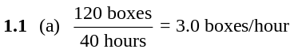
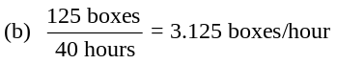
(c) Change in productivity = 0.125 boxes/hour
(d) 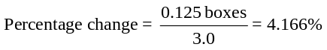
1.2 (a) Labor productivity is 160 valves/80 hours = 2 valves per hour.
(b) New labor productivity = 180 valves / 80 hours = 2.25 valves per hour
(c) Percentage change in productivity = .25 valves / 2
valves = 12.5%
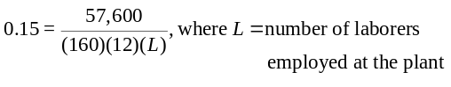1.3
So 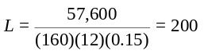 laborers employed
1.4 Bureau of Labor Statistics (stats.bls.gov) is probably as good a place to start as any. Results will vary for each year, but overall data for the economy will range from .9% to 4.8% and mfg. could be as high as 5% and services between 1% and 2%. The data will vary even more for months or quarters. The data are frequently revised, often substantially.
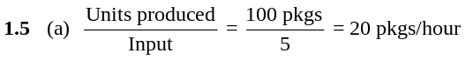
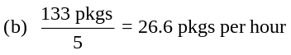
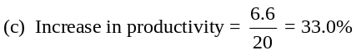
1.6 | Resource | Last Year | This Year | Change | Percent Change
 | Labor | 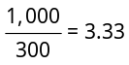 | 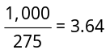 | 0.31 | 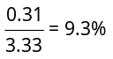
 | Resin | 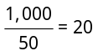 | 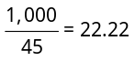 | 2.22 | 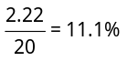
 | Capital | 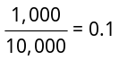 | 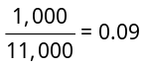 | –0.01 | 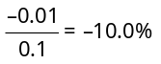
 | Energy | 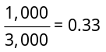 | 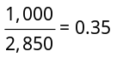 | 0.02 | 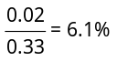
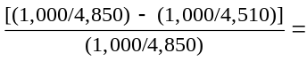


⇒ 7.8% improvement*
* with rounding to 3 decimal places.
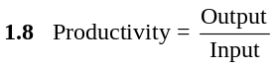
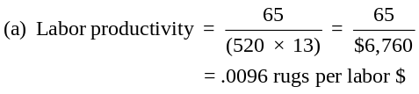
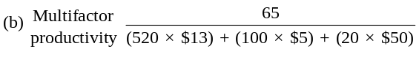
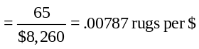
1.9 (a) Labor productivity = 1,000 tires/400 hours = 2.5 tires/hour.
(b) Multifactor productivity is 1,000 tires/(400 ×
$12.50 + 20,000 × $1 + $5,000 + $10,000) =
1,000 tires/$40,000 = 0.025 tires/dollar.
(c) Multifactor productivity changes from 1,000/40,000 to 1,000/39,000, or from 0.025 to 0.02564; the ratio is 1.0256, so the change is a 2.56 percent increase.

1.10 |  | Last Year | This Year | Change | Percent Change
 | Labor hrs. | 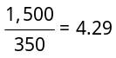 | 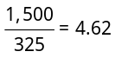 | 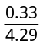 | = 7.7%
 | Capital invested | 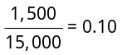 | 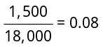 | 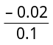 | = –20%
 | Energy (btu) | 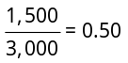 | 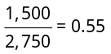 | 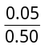 | = 10%
Productivity of capital did drop; labor productivity increased as did energy, but by less than the anticipated 15%.

1.11 Multifactor productivity is:
375 autos/[($20 × 10,000) + ($1,000 × 500) +
($3 × 100,000)] = 375/(200,000 + 500,000 +
300,000) = 375/1,000,000
= .000375 autos per dollar of inputs
1.12 (a) Before: 500/20 = 25 boxes per hour;
1.13 1,500 × 1.25 = 1,875 (new demand)
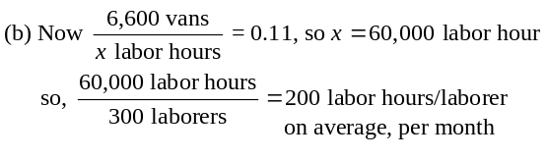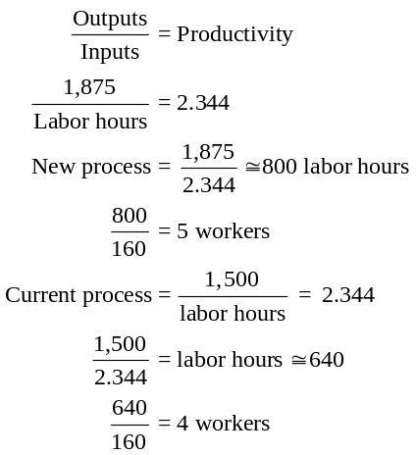
Add one worker.
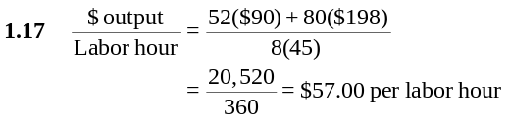1.14 (a) Labor change:
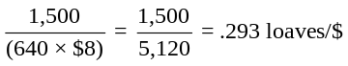
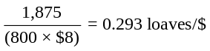
(b) Investment change:
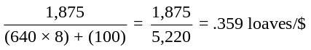
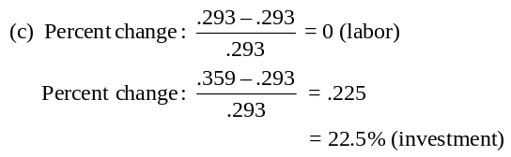
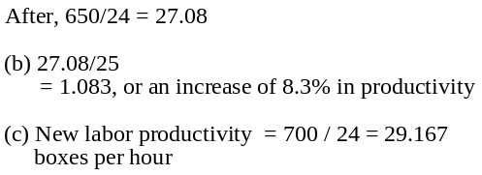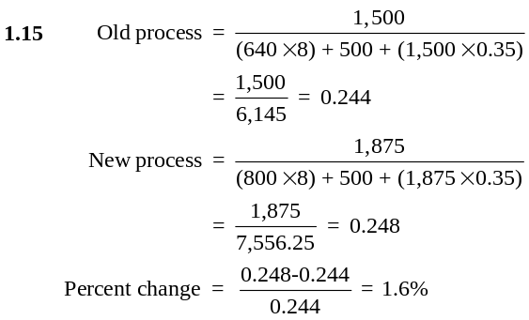
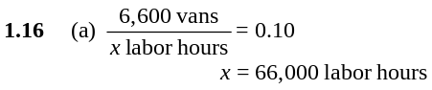
There are 300 laborers. So,
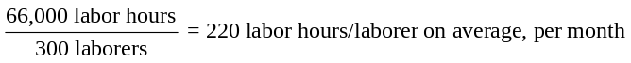
Additional Homework Problems
(found at www.pearsonglobaleditions.com/myomlab.)
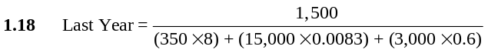
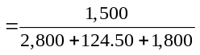
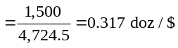
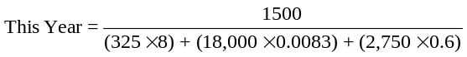
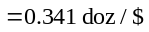
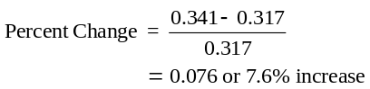
1.19 Global. Its level of integration goes beyond multinational. The collection of parts and subassemblies coming from other countries is carefully orchestrated. It is not transnational because its “home” is clearly the U.S., and there is little sense of “local responsiveness.”

Case Study
NORWEGIAN SALMON PROCESSING FACILITY, TRONDHEIM
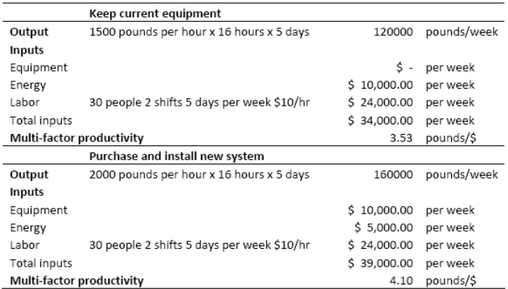

1. What is the productivity of the processing facility using the equipment currently in use?

The current multifactor productivity is 3.53 units output per dollar.

2. What would the productivity of the plant become if the new system is purchased and implemented?

The new multifactor productivity is 4.10 units output per dollar.

3. What would be the amount of additional expense on equip- ment that would make productivity of the two systems equal?

At $16,334 the two multifactor productivities are equal.

4. What might happen if energy costs increase in the future?

This will increase the relative efficiency of the new plant vis-à-vis the older plant.

Video Case Studies
FRITO-LAY: OPERATIONS MANAGEMENT IN MANUFACTURING
1
This case provides a great opportunity for an instructor to stimulate a class discussion early in the course about the pervasiveness of the 10 decisions of OM with this case alone or in conjunction with the Hard Rock Cafe case. A short video accompanies the case.

1. From your knowledge of production processes and from the case and the video, identify how each of the 10 decisions of OM is applied at Frito-Lay:
- Product design: Each of Frito-Lay’s 40-plus products must be conceived, formulated (designed), tested (market studies, focus groups, etc.), and evaluated for profitability.
- Quality: The standards for each ingredient, including its purity and quality, must be determined.
- Process: The process that is necessary to produce the product and the tolerance that must be maintained for each ingredient by each piece of equipment must be specified and procured.
- Location: The fixed and variable costs of the facility, as well as the transportation costs in and the delivery distance, given the freshness, must be determined.
- Layout: The Frito-Lay facility would be a process facility, with great care given to reducing movement of material within the facility.
- Human resources: Machine operators may not have inherently enriched jobs, so special consideration must be given to developing empowerment and enriched jobs.
- Supply chain: Frito-Lay, like all other producers of food products, must focus on developing and auditing raw material from the farm to delivery.
- Inventory: Freshness and spoilage require constant
effort to drive down inventories.
- Scheduling: The demand for high utilization of a capital-intensive facility means effective scheduling will be important.
- Maintenance: High utilization requires good maintenance, from machine operator to the maintenance
department and depot service.
2. How would you determine the productivity of the production processes at Frito-Lay?
Determining output (in some standard measure, perhaps pounds) and labor hours would be a good start for single-factor productivity.
For multifactor productivity, we would need to develop and understand capital investment and energy, as well as labor, and then translate those into a standard, such as dollars.
3. How are the 10 decisions of OM different when applied by the operations manager of a production process such as Frito-Lay than when applied by a service organization such as Hard Rock Cafe?
Hard Rock performs all 10 of the decisions as well, only with a more service-sector orientation. Each of these is discussed in the solution to the Hard Rock Cafe case.

HARD ROCK CAFE: OPERATIONS
MANAGEMENT IN SERVICES
2
There is a short video (7 minutes) available from Pearson Education and filmed specifically for this text that supplements this case.
1. Hard Rock’s 10 Decisions: This is early in the course to dis-
cuss these in depth, but still a good time to get the students engaged in the 10 OM decisions around which the text is structured.
• Product design: Hard Rock’s tangible product is food and like any tangible product it must be designed, tested, and “costed out.” The intangible product includes the music, memorabilia, and service.
• Quality: The case mentions the quality survey as an overt
quality measure, but quality can be discussed from a variety of perspectives—hiring the right people, food ingredients, good suppliers, speed of service, friendliness, etc.
• Process: The process can be discussed from many perspectives: (a) the process of processing a guest, to their seat, taking the order, order processing, delivery of the meal, payment, etc.,
(b) the process of how a meal is prepared (see, for instance, the example box in Chapter 2 on Chef Pierre Alexander), or
(c) some subset of any of these.
• Location: Hard Rock Cafes have traditionally been located in tourist locations, but that is beginning to change.
• Layout: Little discussion in the case, but students may be
very aware that a kitchen layout is critical to efficient food preparation and that a bar is critical in many food establishments for profitability. The retail shop in relation to the restaurant and its layout is a critical ingredient for profitability at Hard Rock.
• Human resources: Jim Knight, VP for Human Resources at Hard Rock, seeks people who are passionate about music, love to serve, can tell a story. This OM decision is a critical ingredient for success of a Hard Rock Cafe and an integral part of the Hard Rock dining experience.
• Supply-chain management: Although not discussed in the case,
students should appreciate the importance of the supply chain in any food service operation. Some items like leather jackets have a 9-month lead time. Contracts for meat and poultry are signed 8 months in advance.
• Inventory: Hard Rock, like any restaurant, has a critical inven-tory issue that requires that food be turned over rapidly and that food in inventory be maintained at the appropriate and often critical temperatures. But the interesting thing about Hard Rock’s inventory is that they maintain $40 million of memora-bilia with all sorts of special care, tracking, and storage issues.
• Scheduling: Because most Hard Rock Café’s sales are driven by tourists, the fluctuations in seasonal, daily, and hourly demands for food are huge. This creates a very interesting and challenging task for the operations managers at Hard Rock. (Not mentioned in the case, linear programming is actually used in some cafes to schedule the wait staff.)
• Maintenance/reliability: The Hard Rock Cafe doors must open every day for business. Whatever it takes to provide a reliable kitchen with hot food served hot and cold food served cold must be done. Bar equipment and point-of-sale equipment must also work.
2. Productivity of kitchen staff is simply the output (number of meals) over the input (hours worked). The calculation is how many
meals prepared over how many hours spent preparing them. The same kind of calculation can be done for the wait staff. In fact,
Hard Rock managers begin with productivity standards and staff
to achieve those levels. (You may want to revisit this issue when you get to Chapter 10 and Supplement 10 on labor standards and discuss how labor can be allocated on a per-item basis with more precision.)
3. Each of the 10 decisions discussed in question 1 can be
addressed with a tangible product like an automobile.
• Product design: The car must be designed, tested, and costed out. The talents may be those of an engineer or operations manager rather than a chef, but the task is the same.
• Quality: At an auto plant, quality may take the form of measuring
tolerances or wear of bearings, but there is still a quality issue.
• Process: With an auto, the process is more likely to be an assembly-line process.
• Location: Hard Rock Cafe may want to locate at tourist destina-
tions, but an auto manufacturer may want to go to a location that
will yield low fixed or variable cost.
• Layout: An automobile assembly plant is going to be organized
on an assembly line criterion.
• Human resources: An auto assembly plant will be more focused on hiring factory skills rather than a passion for music or personality.
• Supply chain: The ability of suppliers to contribute to design and low cost may be a critical factor in the modern auto plant.
• Inventory: The inventory issues are entirely different—tracking
memorabilia at Hard Rock, but an auto plant requires tracking a
lot of expensive inventory that must move fast.
• Scheduling: The auto plant is going to be most concerned with scheduling material not people.
• Maintenance: Maintenance may be even more critical in an auto plant as there is often little alternate routing, and down time is very expensive because of high fixed and variable cost.

Additional Case Study
ZYCHOL CHEMICALS CORPORATION*
1. The analysis of the productivity data is shown below:
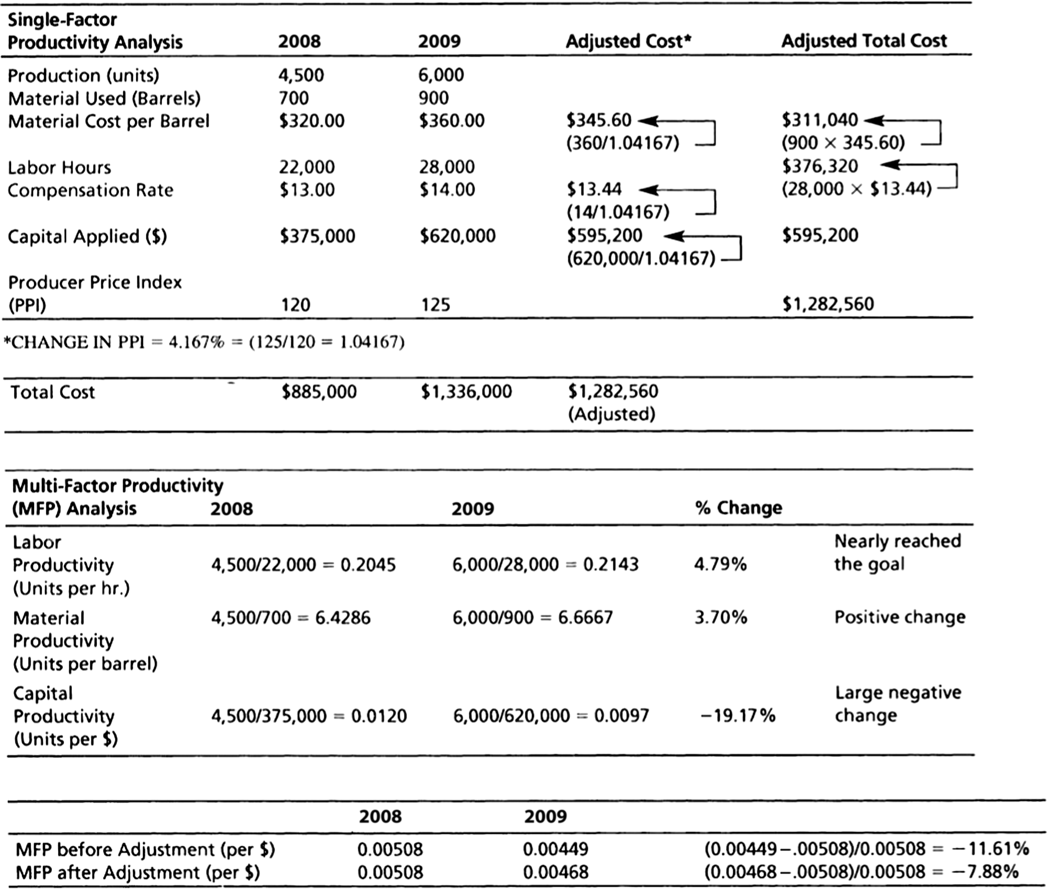

Both labor and material productivity increased, but capital equipment productivity did not. The net result is a large negative change in productivity. If this is a one-time change in the accounting procedures, this negative change should also be a one-time anomaly. The effect of accounting procedures is often beyond the control
of managers. For example, perhaps the capital allocation is based on an accelerated allocation of depreciation of newly installed
technology. This accounting practice will seriously impact near-term productivity and then later years’ productivity figures will benefit from the reduced depreciation flows. This highlights the difficulty in accounting for costs in an effective managerial manner. Decisions and evaluation of operating results should be based on sound managerial accounting practices and not necessarily generally accepted financial accounting principles.
2. An analysis of adjusted results reduces the negative impact on
the capital allocation but there is still a negative growth in multifactor productivity. After adjustment for inflation, the material costs are still higher in 2009. Yet, one must be aware of the extra
volatility of the cost of petroleum-based products. Did the manager have control over his price increases? One should look at the
changes in a petroleum-based price index, including the cost of oil,
over the last two years in order to gain a better understanding of the degree to which the manager had control over these costs. The
increase in wages was beyond the manager’s control and a constant rate should be used for comparing both years’ results. Yet a
negative result still remains. Even when material costs in 2009 are
converted to the original cost of $320, a negative 5% growth in productivity remains. The increase in the capital base is responsi-
ble yet should not persist in future years if the increase was the result of an adoption of new technology.
* This case study is found on our Companion Web sites, www.pearsonglobaleditions.com/heizer and www.pearsonglobaleditions.com/myomlab.com.
3. The manager did not reach the goal. An analysis of the changes in capital costs is warranted. Even after adjusting for in-
flation, multifactor productivity was not positive. However, labor and materials productivity was favorable. The capital investment cost (as figured by the accounting department) was so large as to make his multifactor productivity negative. Multifactor productiv-
ity has fallen by 11.61% before adjustment and by 7.88% after the
adjustment for inflation.

